Sarima Based Forecasting of New Zealand Tourist Arrivals: A Time Series Analysis

Abstract Australia attracts many short-term visitors from New Zealand due to its landscapes, wildlife, and cultural appeal. This study analyzes monthly visitor data (Jan. 1991–Mar. 2025) from the Australian Bureau of Statistics using a SARIMA model to forecast arrivals over the next three years. ACF and PACF plots guided model selection, with the best-fitting model chosen based on AIC and BIC for accurate forecasting and informed tourism planning.
Introduction: Australia has consistently seen a significant number of short-term visitors from New Zealand, contributing to the nation's tourism sector. Understanding and forecasting these visitor patterns is essential for stakeholders such as policymakers, tourism authorities, airlines, and businesses. Time series analysis provides a powerful framework for identifying trends and seasonal patterns, enabling informed decisions that can enhance economic planning and resource allocation.
This study focuses on forecasting monthly short-term visitor arrivals from New Zealand to Australia using time series modelling techniques. Accurate forecasting allows for better preparation and strategic planning, particularly in managing tourism-related infrastructure and services. By identifying underlying patterns in historical data, stakeholders can anticipate future demand and align their operations accordingly.
Methodology
This analysis used a SARIMA model to forecast monthly short-term visitor arrivals from New Zealand to Australia, based on seasonally adjusted data from January 1991 to March 2025. A log transformation was applied to stabilize variance, and stationarity was assessed using the Augmented Dickey-Fuller (ADF) test. Model orders were selected by examining ACF and PACF plots, and several SARIMA models were evaluated using AIC and BIC criteria. The best-fitting model was checked for residual autocorrelation and normality, and forecasts were produced for the period January 2026 to December 2028.
Objective: The main goal is to forecast the number of short-term visitors from New Zealand and predict the outcomes for the next three years. The analysis uses SARIMA modelling to support decision-making for tourism stakeholders.
Overview of modelling choices.
Several time-series techniques could be applied to forecast New-Zealand visitor arrivals. Spatial models are useful when visitor flows differ across regions, and intervention analysis is ideal when the series contains discrete shocks or multiple structural breaks that are best modelled piecewise. In our data, however, the dominant feature is a single long-run upward trend and strong seasonality. Therefore, a seasonal ARIMA (SARIMA) model was employed to capture these remaining seasonal effects. Decomposition reveals a seasonal pattern in the time series plot as shown in figure 3. A Seasonal ARIMA (SARIMA) framework is therefore appropriate because it captures both non-seasonal and seasonal dynamics in one unified model. Before fitting SARIMA, we perform a classical decomposition to separate trend, seasonality, and noise. Modern alternatives such as STL or SEATS could also be used, but classical decomposition suffices for visual diagnostics and keeps the workflow transparent.
Data Description:
The data was collected from ABS (Australian bureau of statistics) with the title as “Overseas Arrivals and Departures, Australia” where table 5 was downloaded to find the relevant data set for the purpose of modelling. The table contains a list of short-term visitors from January 1991 to March 2025 for different countries. Only the date column and the number of visitor’s column from New Zealand was extracted in a separated excel file and saved as a csv file to be used in R studio for the purposes of modelling and analysis. We are interested in the Visitor’s column as it will aid us in doing the forecasting.
Data Visualization and Transformation:
The original dataset displays an upward trend with seasonality, followed by a steep drop in March 2020, most likely due to travel restrictions imposed during the COVID-19 pandemic. This pattern can be observed in Figure 1.
Figure 1. Number of NZ visitors to Australia from January 1991 to March 2025
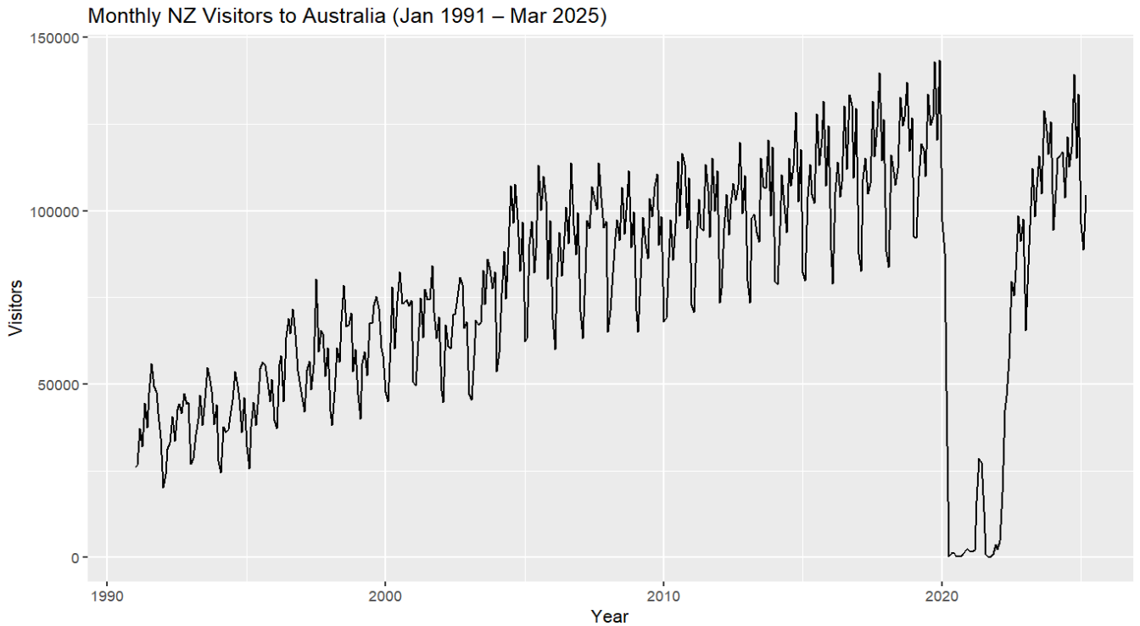
To apply SARIMA modelling effectively, it is necessary to stabilize the increasing variance. A logarithmic transformation is commonly used to stabilize variance. The log-transformed data, shown in Figure 2, provides a more stable base for further modelling.

Figure 2. Log transformed data to stabilize the variance
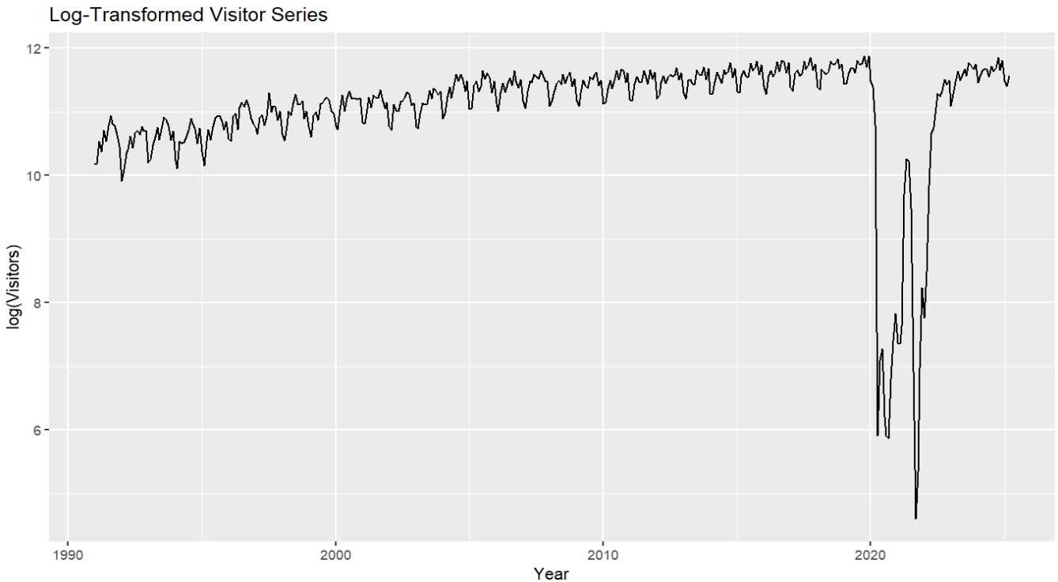
We can see that the variance is stabilized now in figure 2. We can move forward by making the series stationary.

Stationary, Non-Stationary and Decomposition
To build a reliable forecasting model, the time series must be stationary, meaning it has constant mean and variance over time. While variance stabilization was addressed through logarithmic transformation, the seasonal stability is examined next through differencing.
To better understand the structure of the series, classical decomposition was performed. This separates the original series into trend, seasonality, and random noise components. Such decomposition provides insight into the series' non-stationary behaviour and guides the transformation process.
To achieve stationarity, we applied seasonal differencing. First order differencing was not required as logarithmic time series was already stationary which was validated using the Augmented Dickey-Fuller (ADF) test (table 1). A p-value less than 0.05 indicates that the null hypothesis of non-stationarity can be rejected, confirming stationarity.
The plot for decomposition is shown in figure 3.
Figure 3 Classical Decomposition of the time series plot
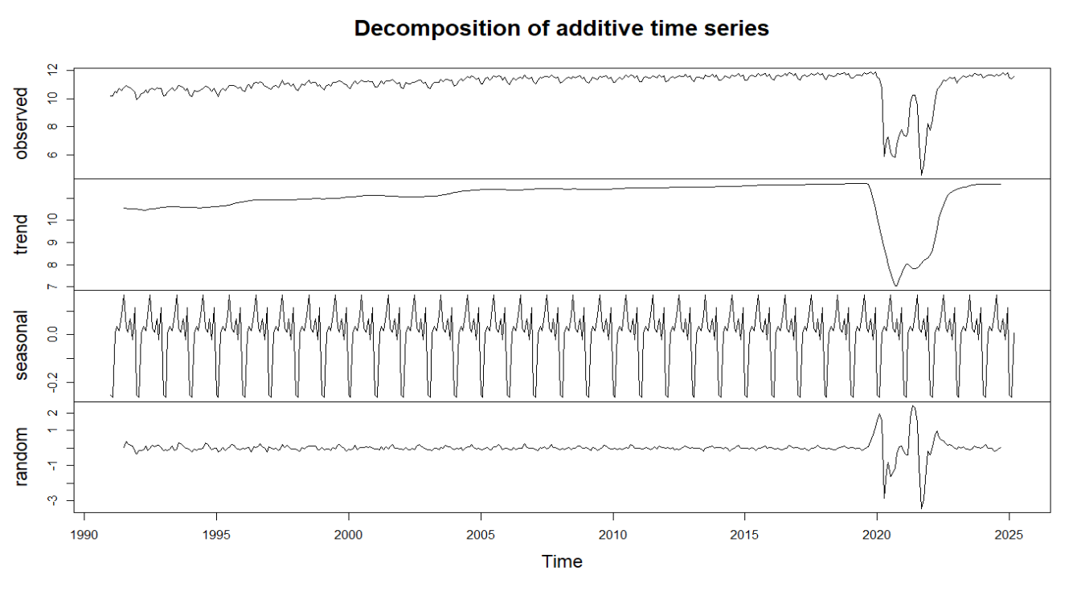
Here in figure 3 we can visualize the pattern of the time series in terms of trend, seasonality and random noise in the time series plot. We will deal with the seasonality through seasonal differencing.
Results of the ADF tests before and after differencing are presented in Table 1 and Table 2.

Statistic | P-value
-3.6225 | 0.03
Statistic | P-value
-5.2814 | 0.01
Table 1. Non-Stationary ADF Table 2. Stationary ADF

The results of the Augmented Dickey-Fuller (ADF) tests conducted in R studio are summarized in Table 1 and Table 2, showing values before and after differencing. Based on the p-value in Table 2, we can conclude that the series is now stationary after applying differencing. Figure 4 shows the seasonally differenced series.

Figure 4 Seasonally differenced
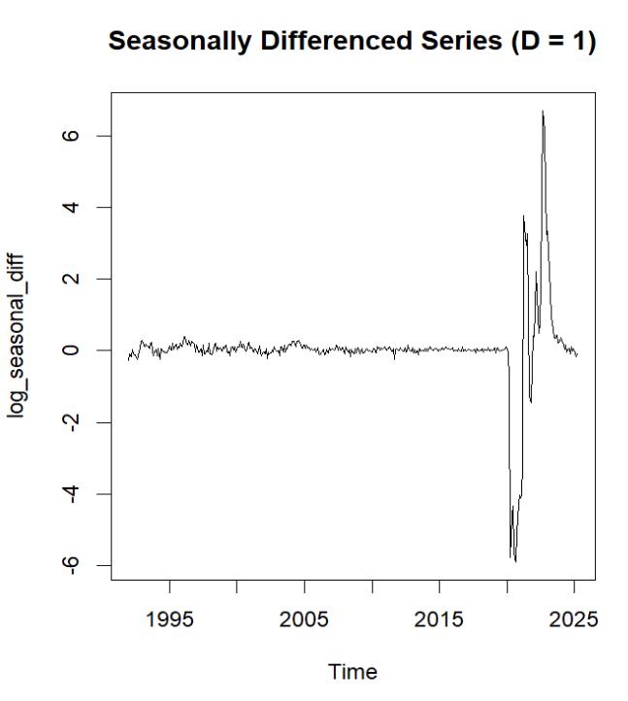

4. Model Identification
To identify an appropriate SARIMA model, we analyze the Auto-Correlation Function (ACF) and Partial Auto-Correlation Function (PACF) plots, which help determine the non-seasonal (p,d,q) where p = order of the autoregressive part, d = degree of first differencing involved and q = order of the moving average part (Hyndman & Athanasopoulos, 2021, Section 9.5) and seasonal (P,D,Q)[m] parameters of the model, where m= the seasonal period. (Hyndman & Athanasopoulos, 2021, Section 9.9). ACF and PACF plots are interpreted based on two key behaviours’, cut-off and tailing off. A cut-off occurs when there's a sharp drop in correlation after a certain lag, indicating a likely order for an MA process (from ACF) or AR process (from PACF). Tailing off, in contrast, refers to a gradual decline in spikes, suggesting the opposite component. For instance, if the ACF cuts off at lag 1 and the PACF is exponentially decaying or sinusoidal, an MA(1) model is appropriate whereas if the PACF cuts off and the ACF exponentially decaying or sinusoidal, an AR(1) model is suitable. (Hyndman & Athanasopoulos, 2021, Section 9.5). For seasonal components, we focus on lags 12, 24, and 36, since the data is monthly. Significant spikes at these seasonal lags help identify the seasonal parameters P, D, and Q. Using these rules, we can determine plausible SARIMA configurations to test further using model selection criteria like Akaike Information Criterion (AIC) and Bayesian Information Criterion (BIC). Both are model selection criteria used to compare how well different statistical models fit the data. Lower values indicate a better model.
Now we will investigate how we create the Sarima process by analyzing the ACF and PACF plots in figure 5 and figure 6.
Figure 5. ACF Plot Figure 6. PACF Plot
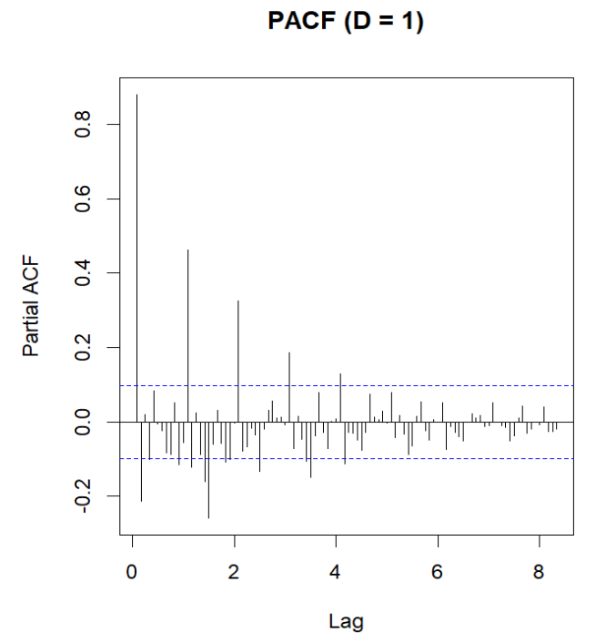
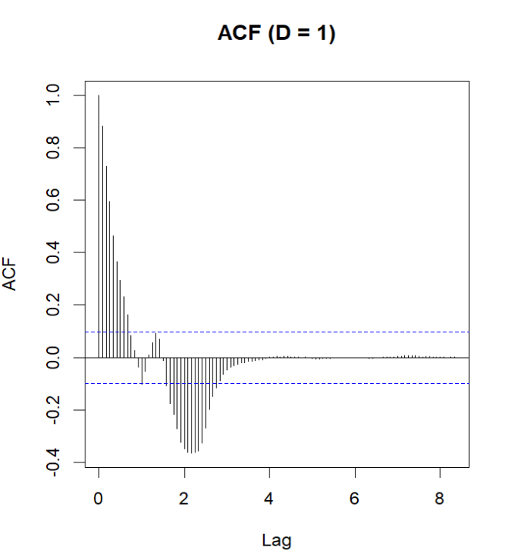

The ACF plot in Figure 5 shows a sinusoidal, slowly decaying pattern rather than sharp seasonal spikes, suggesting the presence of a non-seasonal moving average (MA) component. The PACF in Figure 6 exhibits a clear cut-off at lag 1, with subsequent lags gradually declining, which supports the inclusion of a non-seasonal autoregressive (AR) term. These patterns justify using an ARMA(1,1) structure for the non-seasonal component, with no first-order differencing applied (d=0), as the log-transformed series was already trend-stationary.
For the seasonal component, the ACF shows some mild persistence around seasonal lags, though not strongly pronounced. A seasonal differencing (D=1) was applied to address the regular 12-month seasonal pattern observed in the original series. The inclusion of a seasonal MA(1) term (Q=1) is supported by the remaining autocorrelation at lag 12 in the ACF. The PACF shows strong seasonality at 12, 24 and 36 confirming strong seasonal component therefore the inclusion of AR(1) term (P=1) is supported by the time series.
As a result, the SARIMA(1,0,1)(0,1,1)[12] model was selected as the primary candidate. To assess its robustness, four additional models with nearby parameter combinations were fitted and compared using AIC and BIC criteria, as shown in Table 3. These alternatives help confirm the selected model’s balance between simplicity and forecasting adequacy.

Table 3. Sarima candidate models along with their corresponding AIC and BIC values
Models | AIC | BIC
Sarima (0,0,1)x(1,1,0)₁₂ | 846.15 | 858.12
Sarima (1,0,0)x(0,1,1)₁₂ | 390.21 | 402.17
Sarima (1,0,1)x(1,1,0)₁₂ | 508 | 523.96
Sarima (1,0,1)x(0,1,1)₁₂ | 370.23 | 386.19
Sarima (0,0,1)x(0,1,1)₁₂ | 785.6 | 797.57

Table 3 shows that SARIMA(1, 0, 1)(0, 1, 1)[12] yields the lowest AIC and BIC, and is therefore selected as the final model. Where AIC = 370.23 , BIC = 386.19
The next step is to check for residuals and do Ljung-box test to find and check for autocorrelation, normality and variability.
Figure 7 Residual Analysis
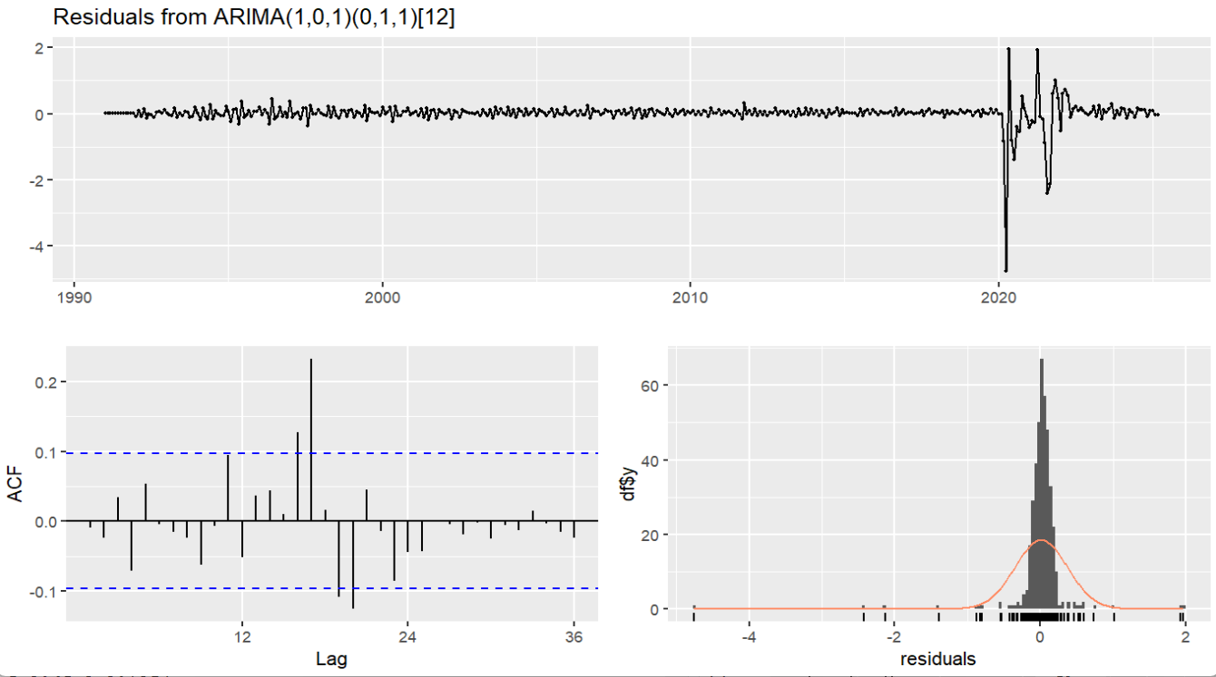
Figure 7 displays the residual diagnostics for the selected SARIMA model. The residuals appear to have constant variance and are cantered around zero, indicating no major issues with heteroscedasticity or bias. However, the ACF plot reveals some remaining autocorrelation, suggesting that the model has not fully captured all the structure in the data. Additionally, the histogram of residuals shows a right-skewed distribution, indicating a deviation from normality. While these diagnostics are not ideal, such issues are common in time series models and do not necessarily undermine the model's usefulness for forecasting purposes. The model is therefore considered reasonably adequate, with limitations clearly acknowledged

Table 4. Ljung-box and Shapiro wilk results
Tests | P-values
Ljung-box | 2.358 x 10⁻⁵
Shapiro wilk | 2.2 x 10⁻¹⁶

In table 4 the Ljung-box test proves there is significant no-auto correlation in the residuals and the Shapiro wilk test confirms that the residuals are not normally distributed.
Now we will be doing our final forecasting using our chosen Sarima model as shown in figure 8.
Figure 8. The 3-year forecast using Sarima model
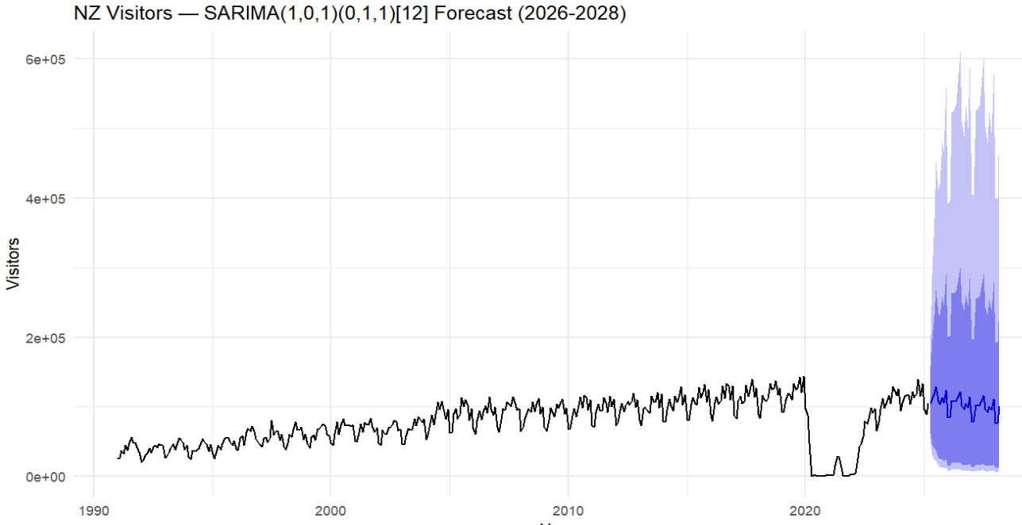

Discussion and limitations
The study primarily applied the Box-Jenkins methodology, which involves three key steps: analyzing the ACF and PACF plots to identify candidate models, evaluating model performance using AIC and BIC scores, and checking residuals for autocorrelation and normality. The final step involved generating a three-year forecast for short-term visitors from New Zealand to Australia. To address issues of non-constant variance and non-stationarity, a logarithmic transformation and differencing were applied. Based on model selection criteria, the SARIMA(1,0,1)(0,1,1)[12] model was chosen due to its lowest AIC and BIC values, indicating the best overall fit among the evaluated models.

Limitations
The Ljung-Box test indicates that residuals are not completely white noise, suggesting some remaining structure not captured by the model.
The residuals are not normally distributed, which may affect the accuracy of forecast intervals.
Although the model forecasts for 2026–2028, disruptions from 2020 may still have influenced the model’s structure due to extreme values in the data.
Only five SARIMA models were tested, other configurations or modelling approaches may have provided better performance.

Conclusion
The SARIMA(1,0,1)(0,1,1)[12] model captures the main trend and seasonality in visitor arrivals and provides reasonable forecasts for 2026–2028. While some residual autocorrelation and non-normality remain, the model still offers useful insights for short-term tourism planning. With further refinement, its forecasting accuracy could be improved. Modelling with intervention time series rather than Sarima could have been a better approach

References
- Hyndman, R. J., & Athanasopoulos, G. (2021). Forecasting: Principles and practice (3rd ed.). OTexts. https://otexts.com/fpp3/

- Australian Bureau of Statistics. (2025, May 13). Overseas arrivals and departures, Australia. Australian Bureau of Statistics. https://www.abs.gov.au/statistics/industry/tourism-and-transport/overseas-arrivals-and-departures-australia/latest-release

